Instructions: Choose and implement a set of tools from the provided Labs-Kali manual.

* I decided to start at the beginning, with the information gathering list. I will first provide a screenshot of the tool instruction and then I will provide the steps and the results that I obtained from using the tool. Below is a screenshot of the tools that I’ll run using Kali’s command prompt.

/var/folders/mk/fk72nzxj08q1lr99rp_zwxn00000gn/T/com.apple.Preview/com.apple.Preview.PasteboardItems/Labs-Kali (dragged).pdf

/var/folders/mk/fk72nzxj08q1lr99rp_zwxn00000gn/T/com.apple.Preview/com.apple.Preview.PasteboardItems/Labs-Kali (dragged) 1.pdf

1. Source that I used to make this tool work: <https://www.youtube.com/watch?v=0q9_NDbOPbQ>
2. The green box shows the commands and the results.

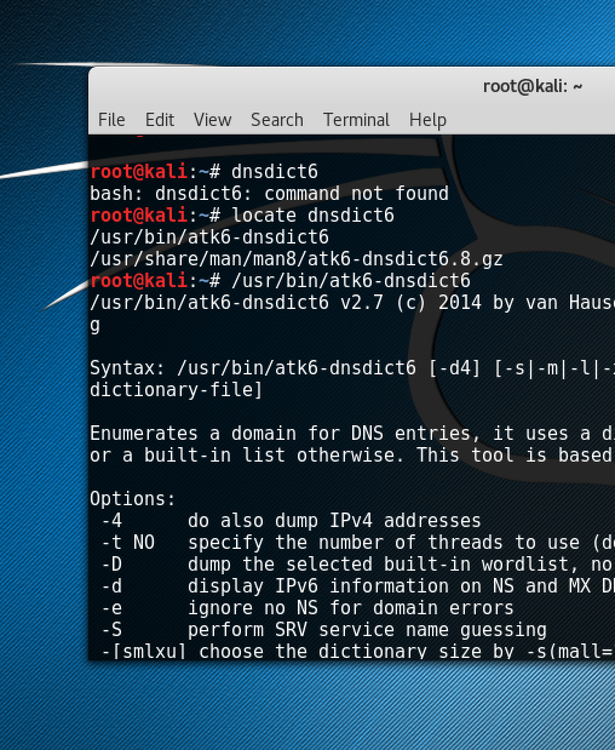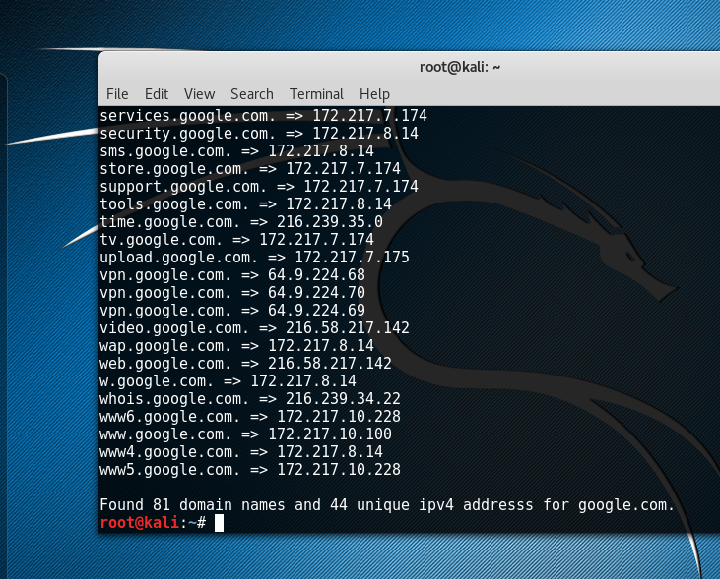



1. After some trial and error, the command that I used was: /usr/bin/dnsenum –fa google.com
2. The green box shows the commands and the results.

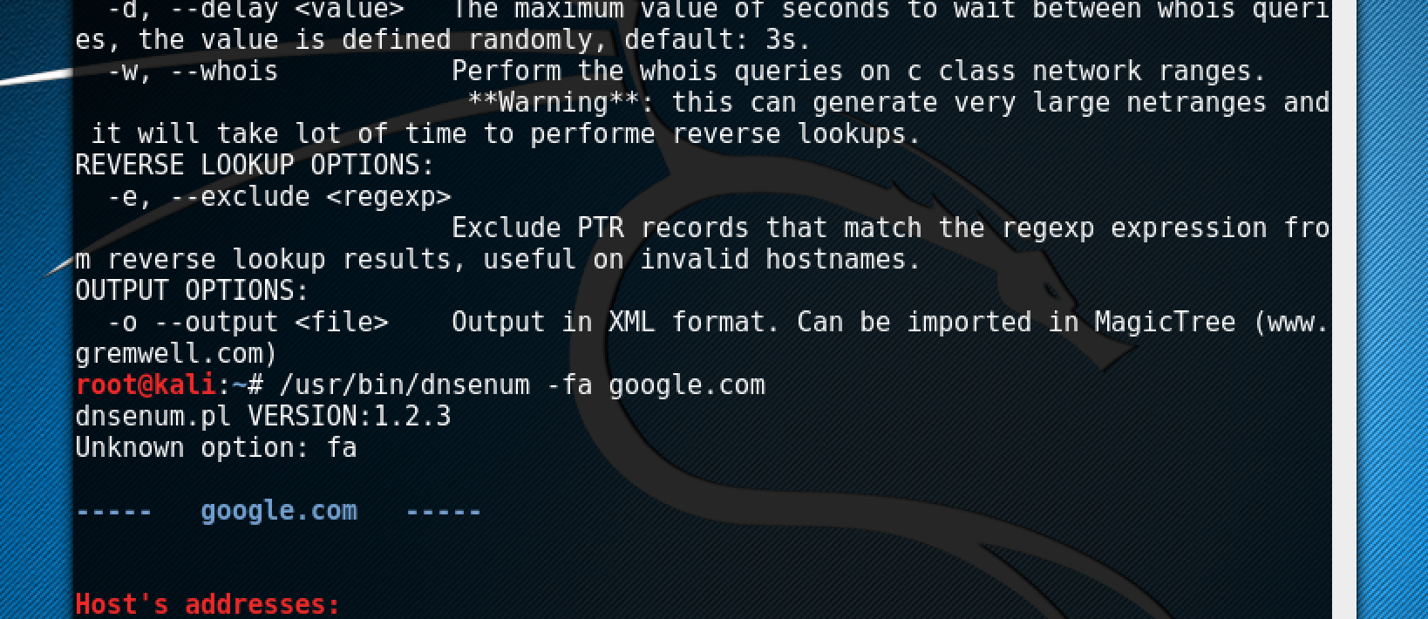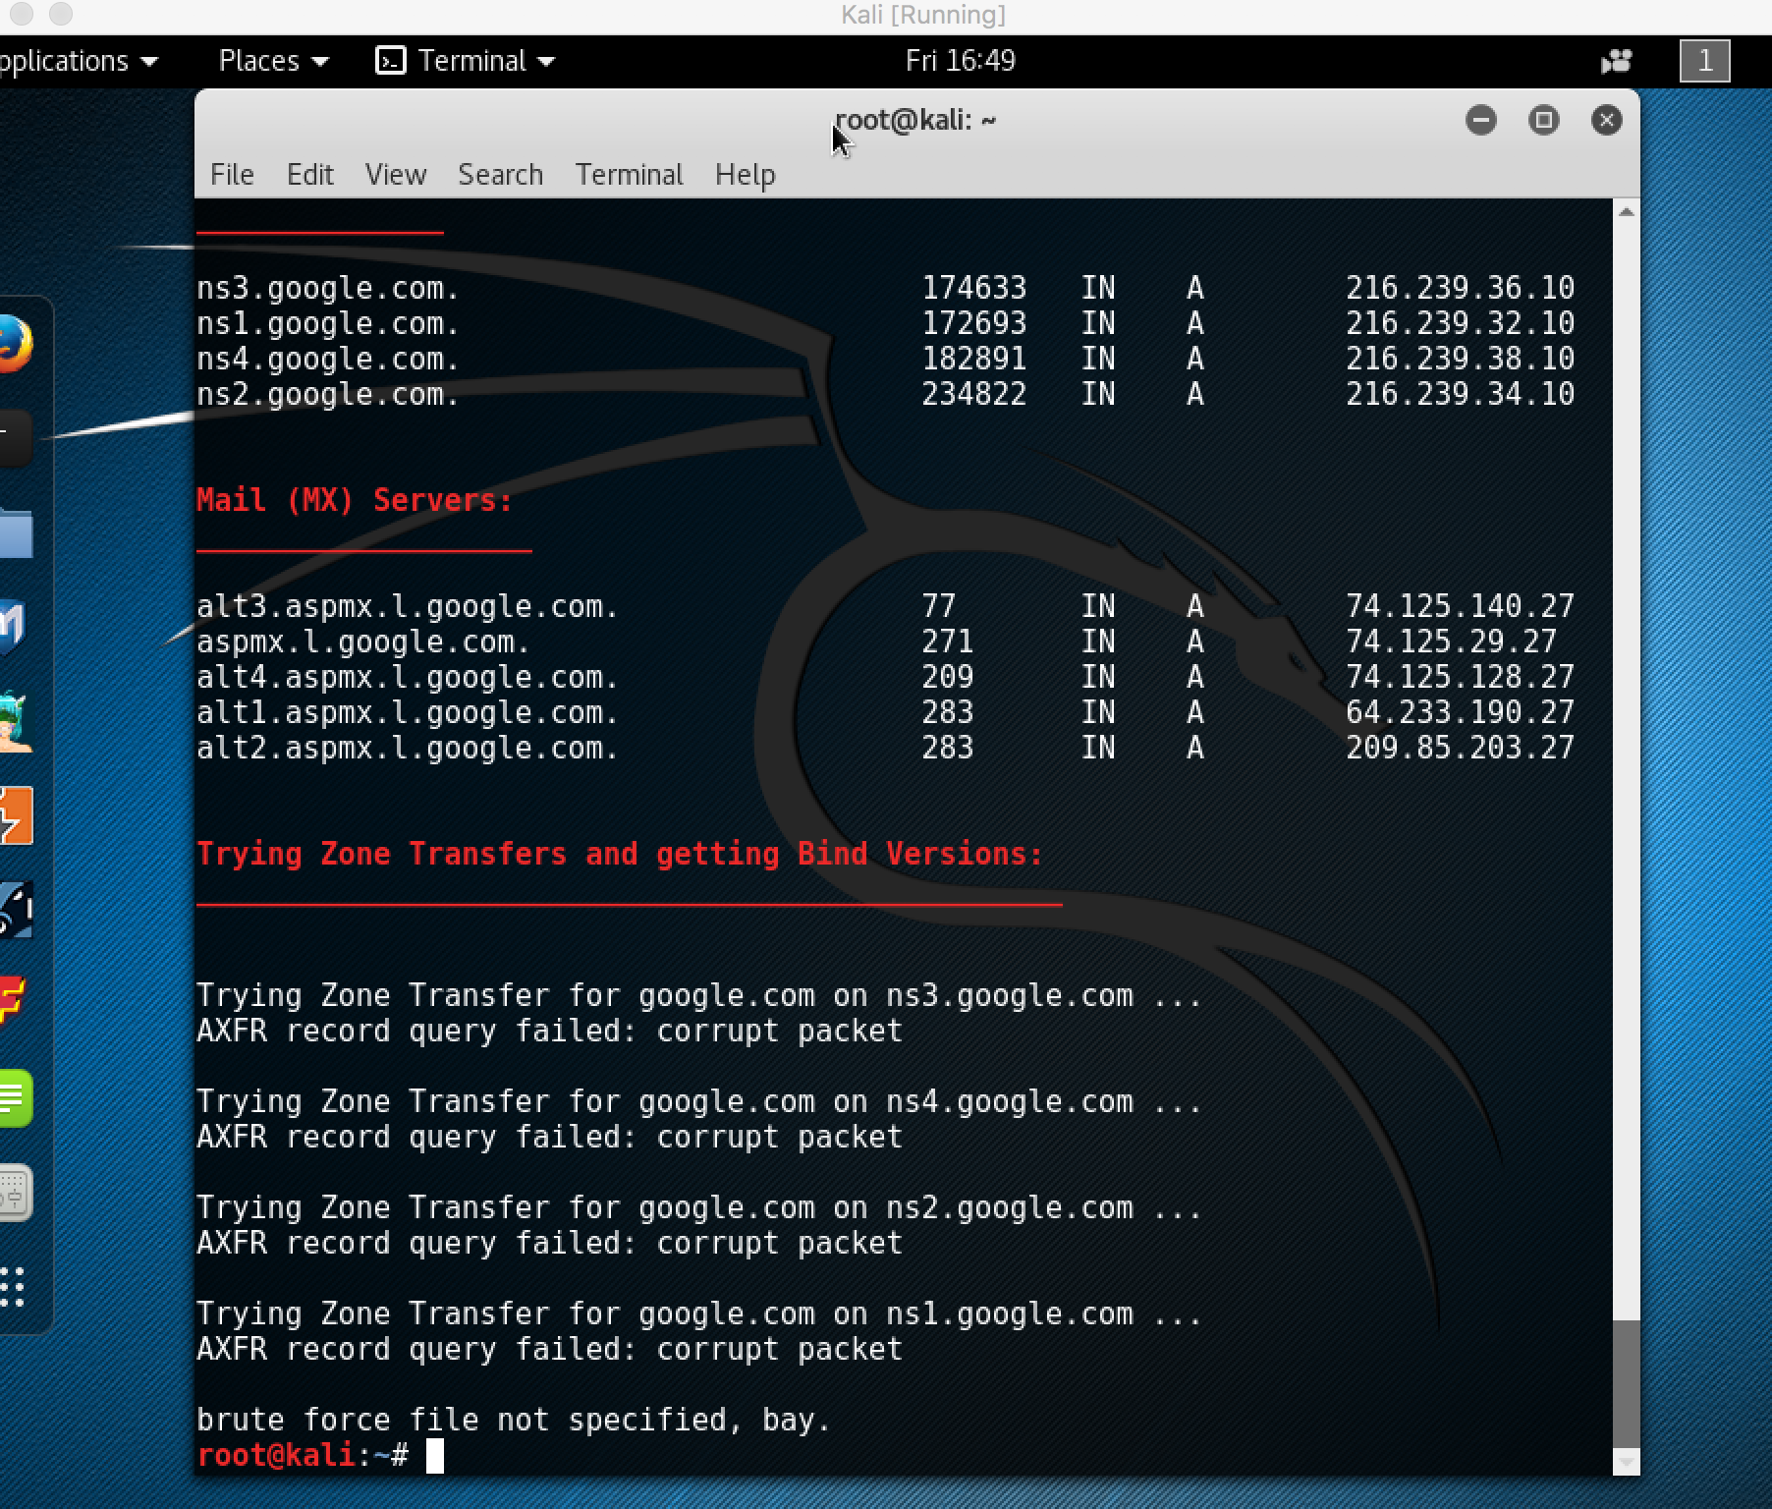



1. The command that I used was: /usr/bin/dnsmap google.com
2. The green box shows the commands and the results.

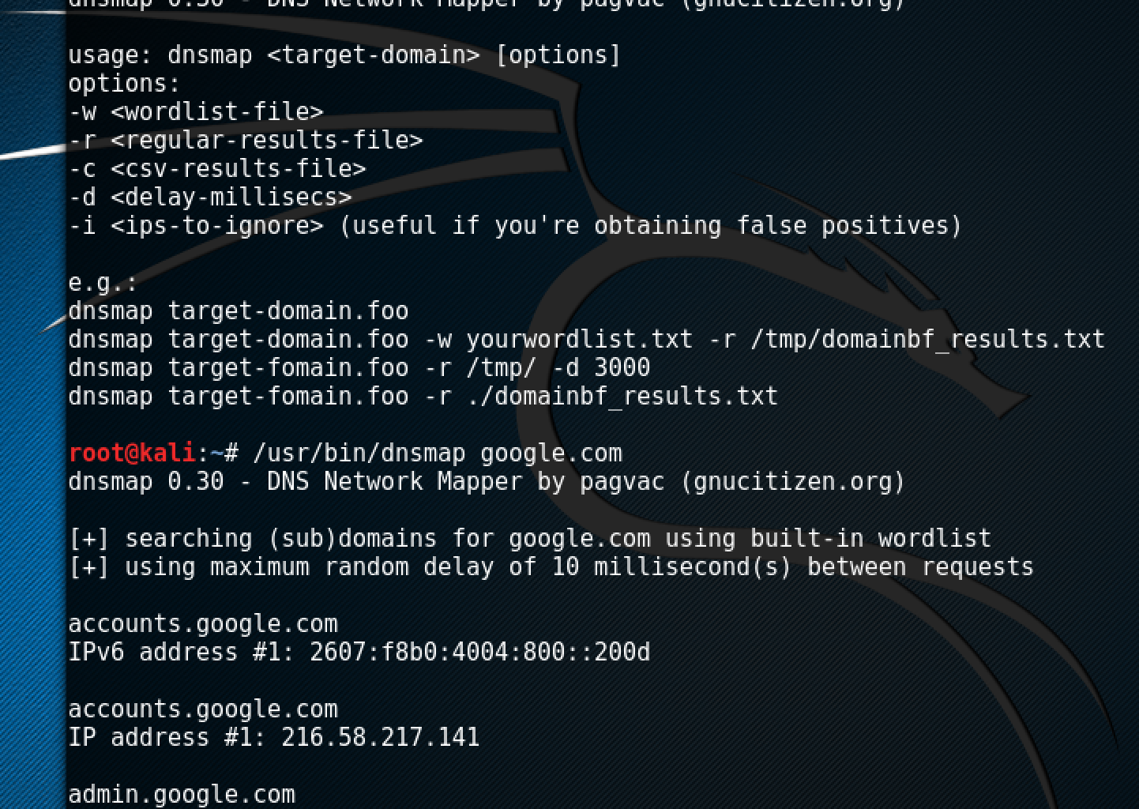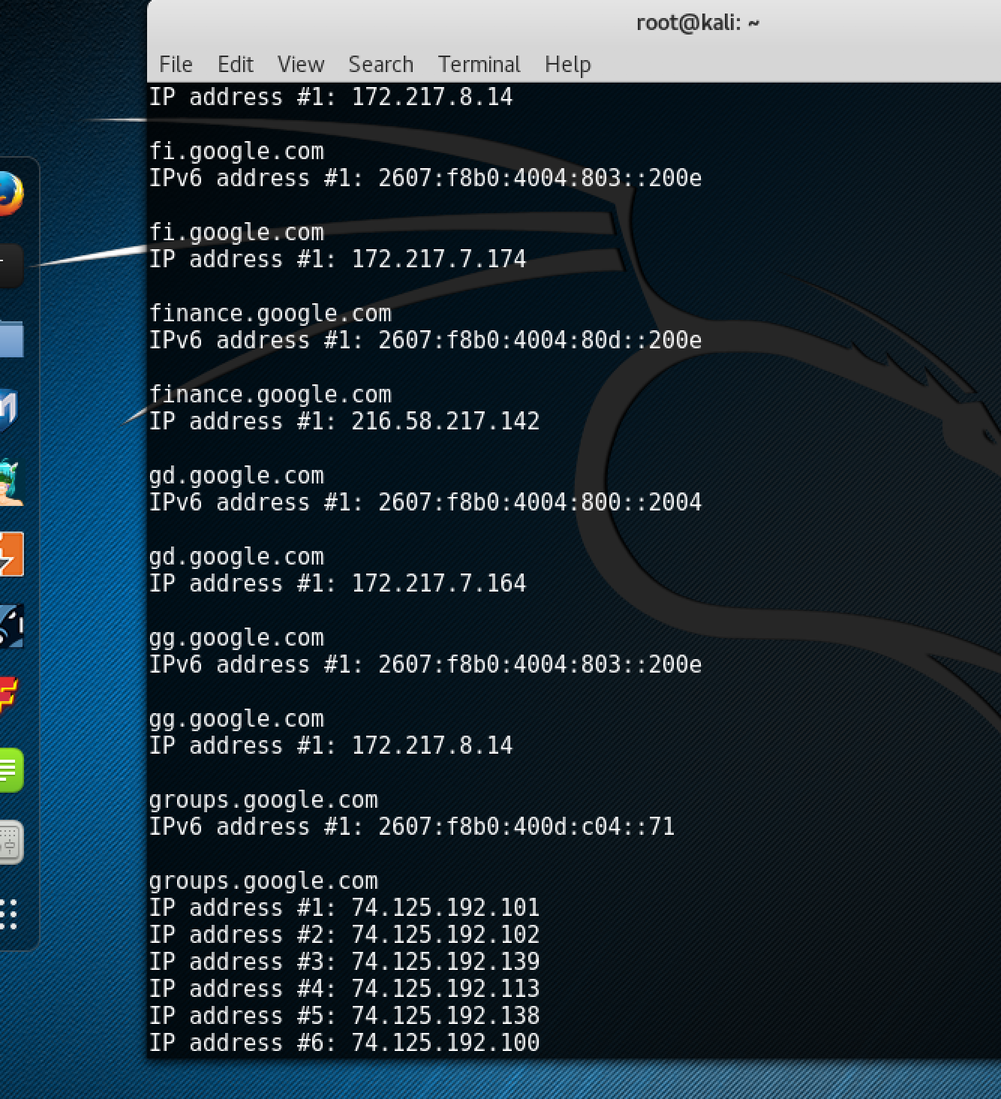



1. The command that I used was: /usr/bin/dnsrecon -d google.com
2. The green box shows the commands and the results.

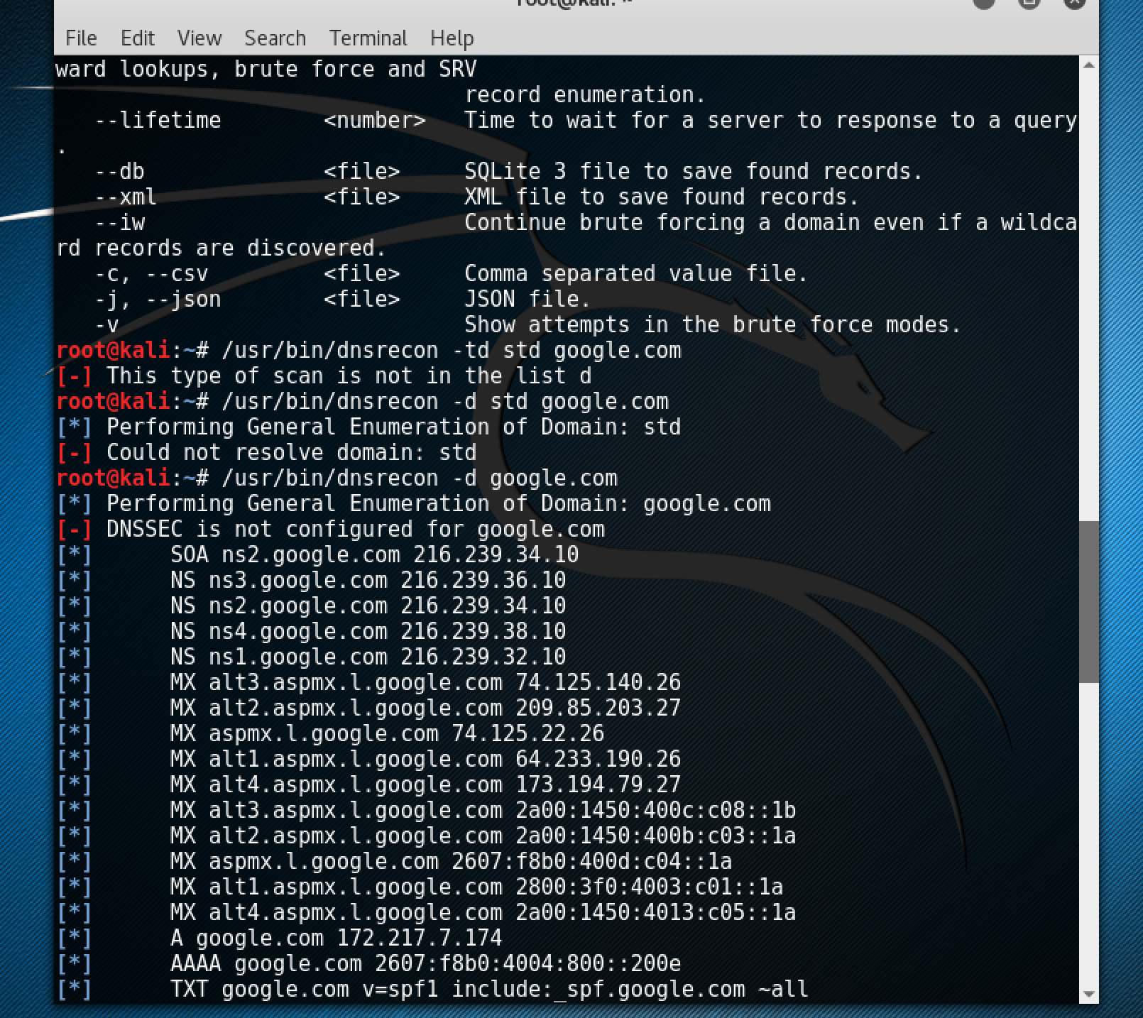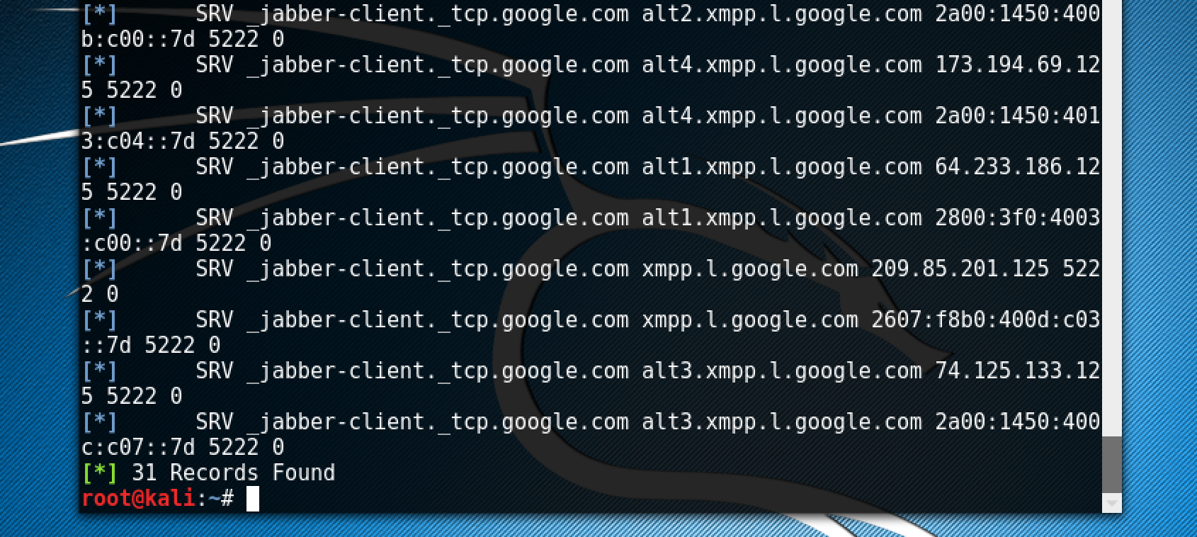



1. With a little trial-and-error, the command that I used was: /usr/bin/atk6-dnsrevenum6 dns.test.com 2001:db8:42a8::/48
2. The green box shows the commands and the results.

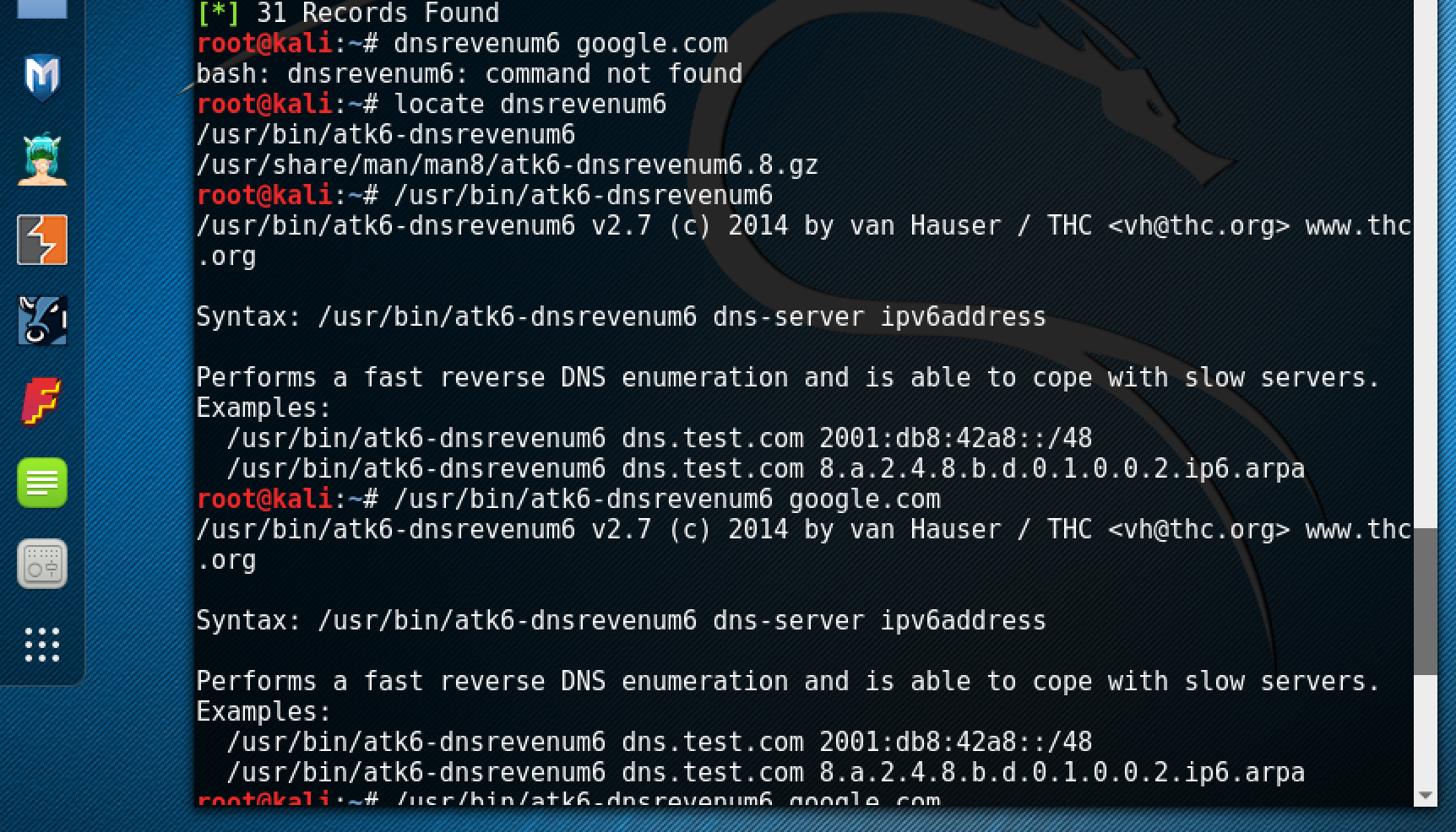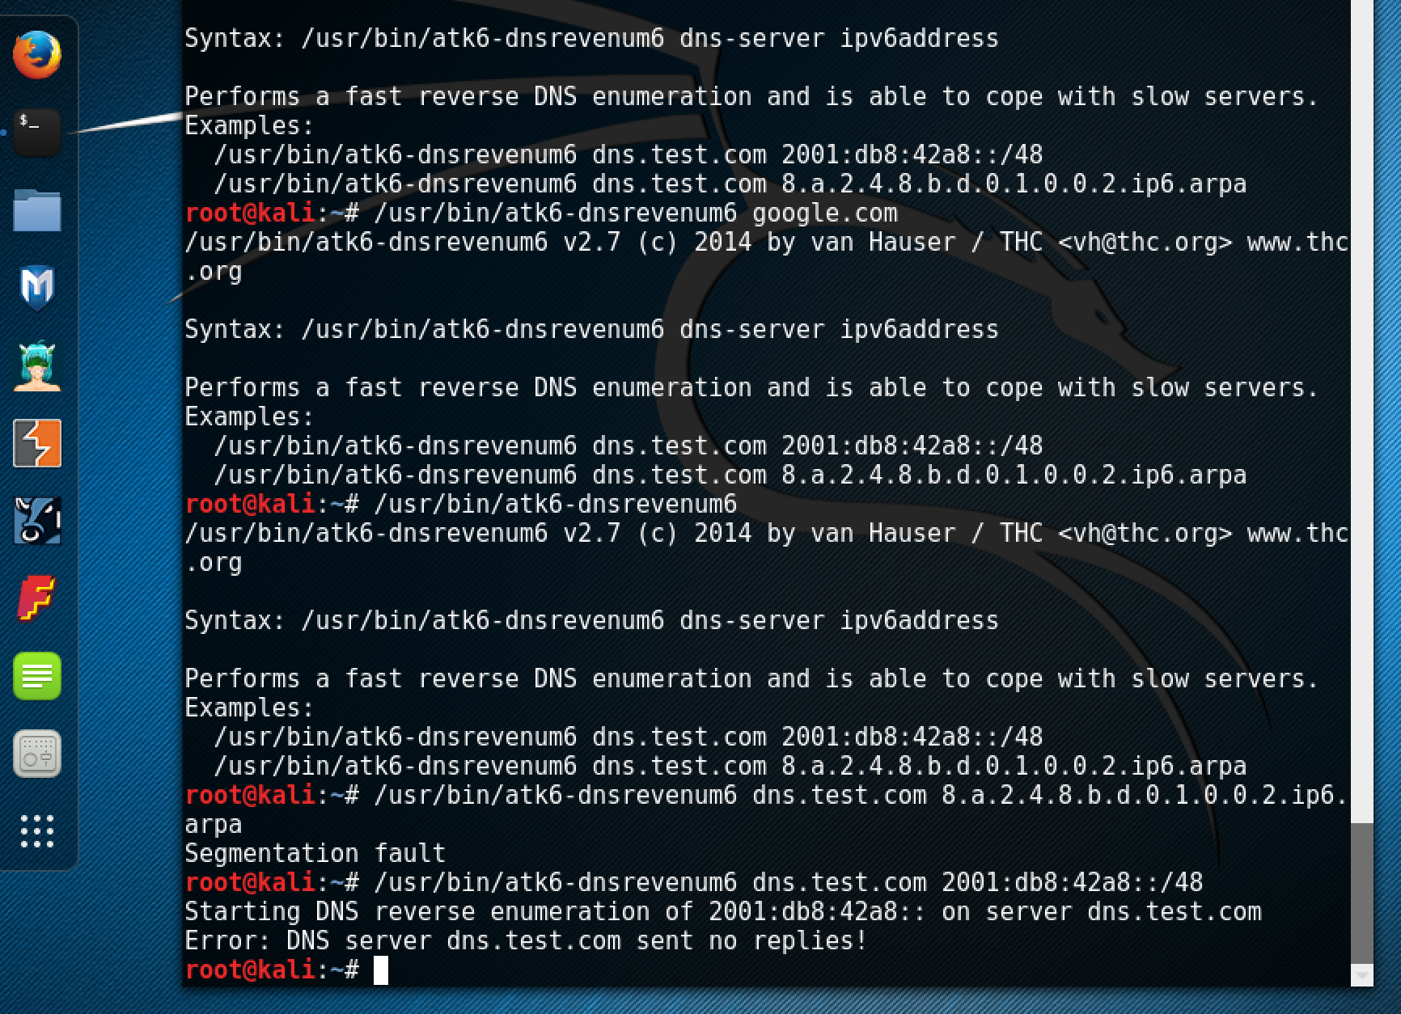



1. The command that I used was: /usr/bin/dnstracer google.com
2. The green box shows the commands and the results.

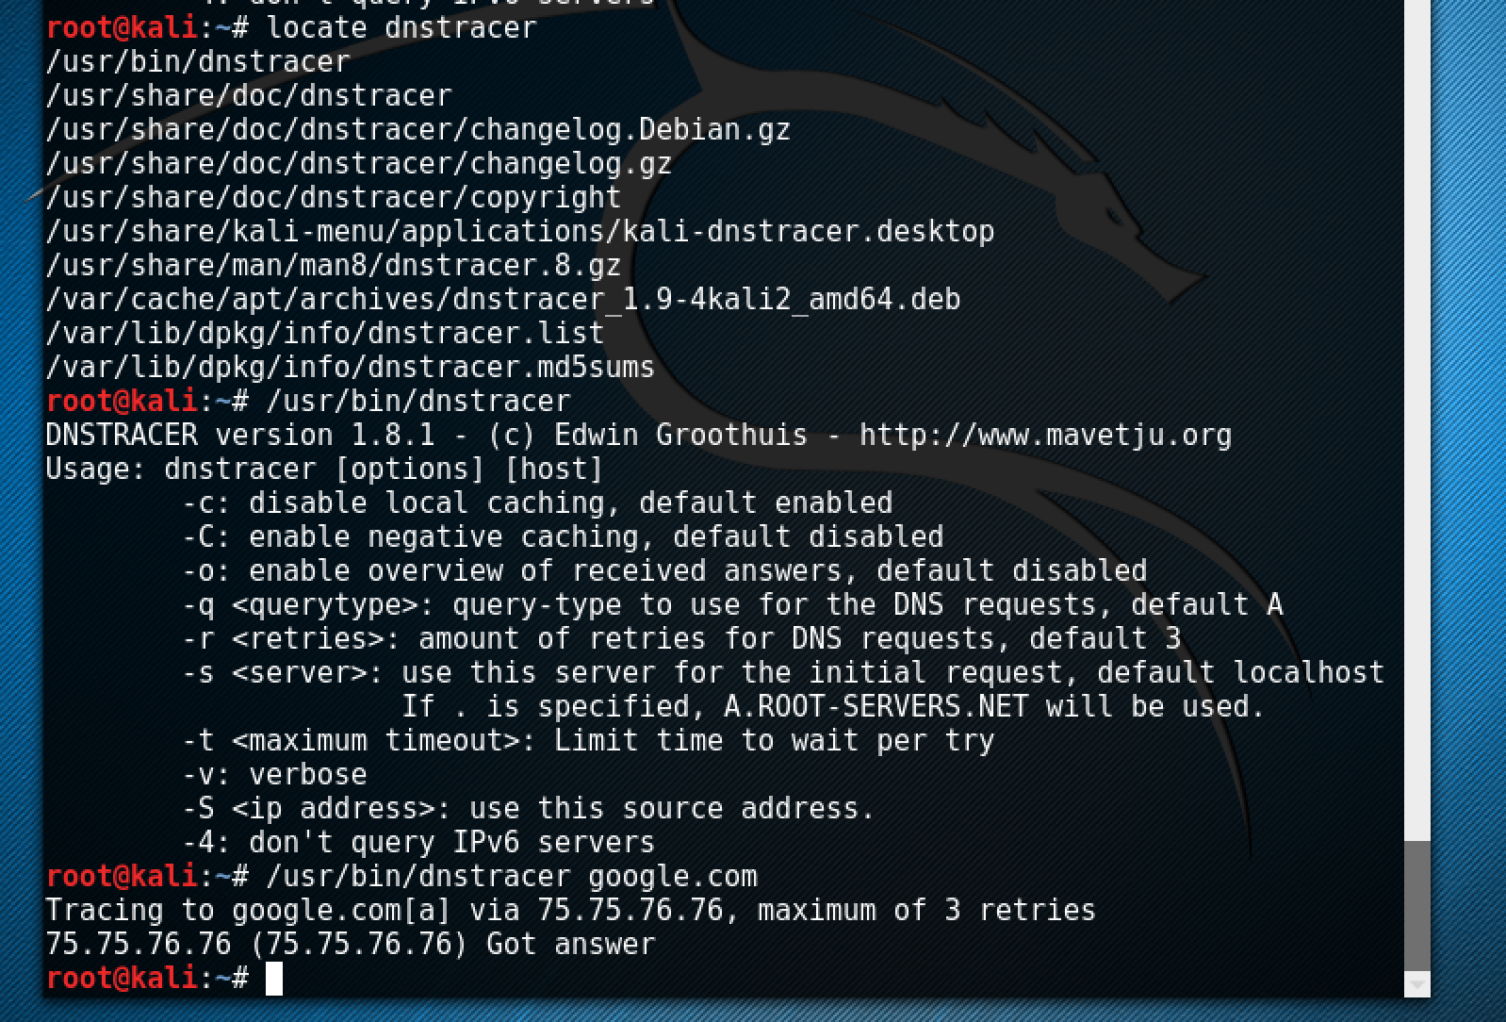



1. The command that I used was: /usr/bin/dnswalk google.com.
2. The green box shows the commands and the results.



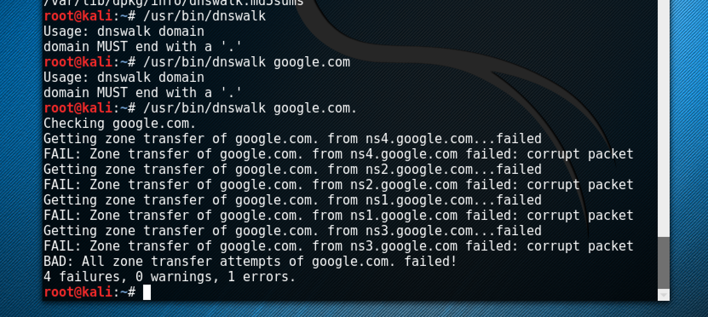



1. The command that I used was: /usr/bin/fierce -dns google.com
2. The green box shows the commands and the results.

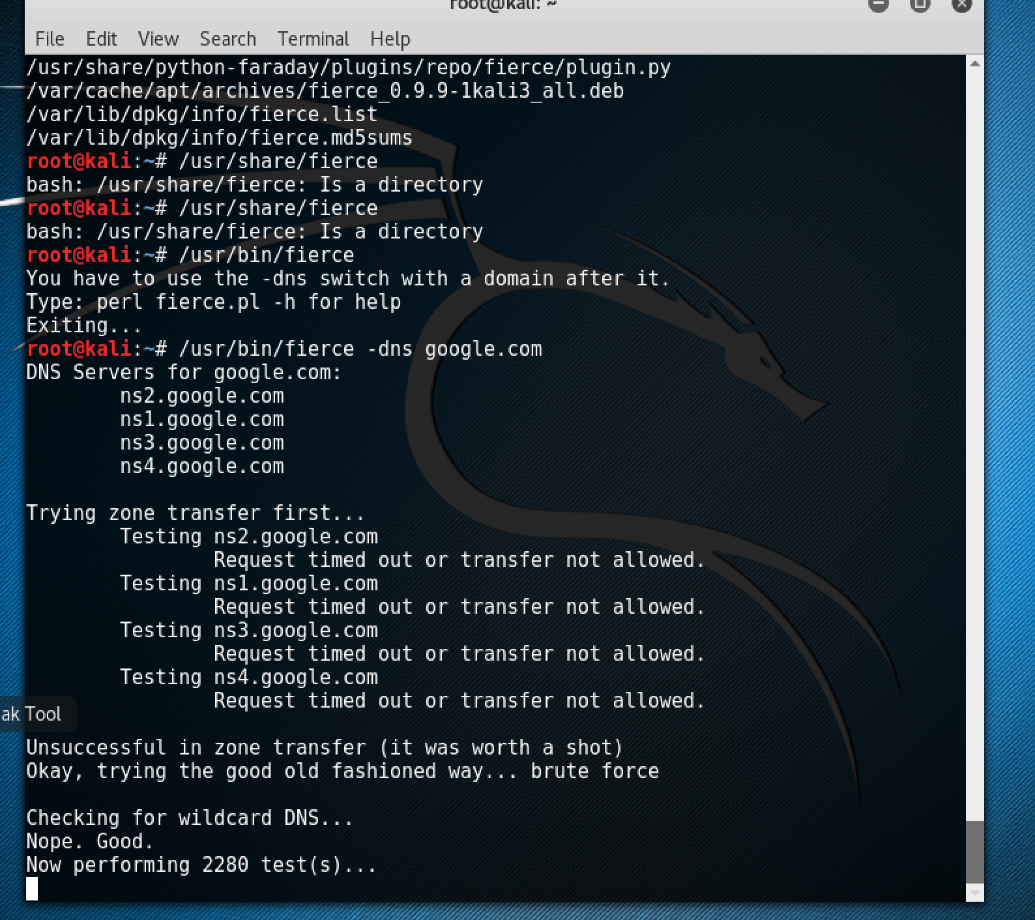



1. First, I used the locate maltego command; then I used: /usr/bin/maltegoce
2. This opened an application called: Maltego\_Chlorine

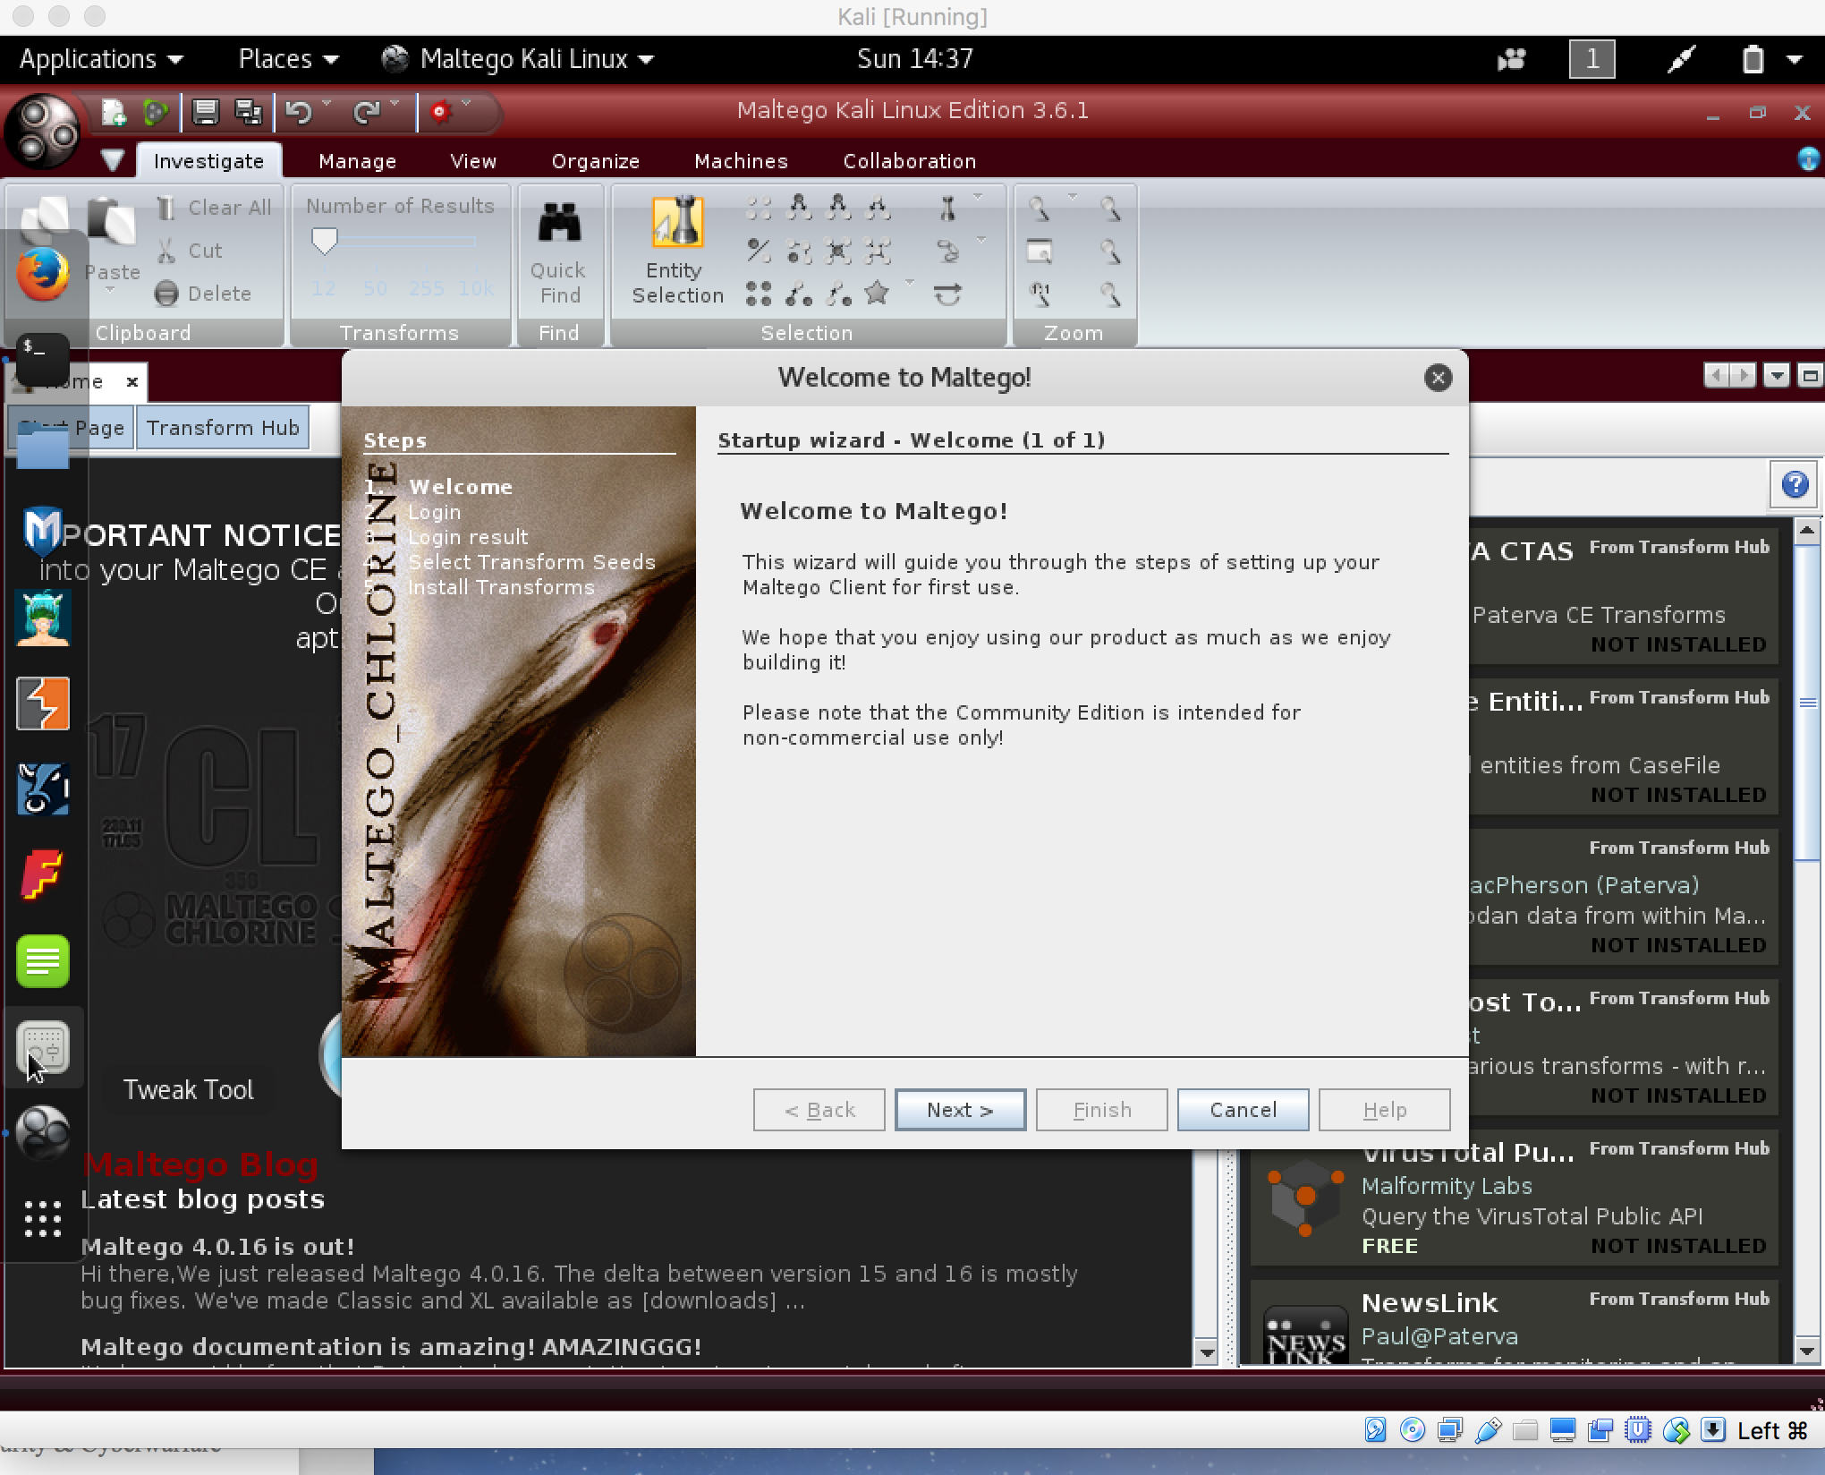



1. First, I used the locate command; then, I found my ip address.
2. The command that I used was: /usr/bin/dnmap\_client –sp 10.0.0.211
3. The green box shows the commands and the results.

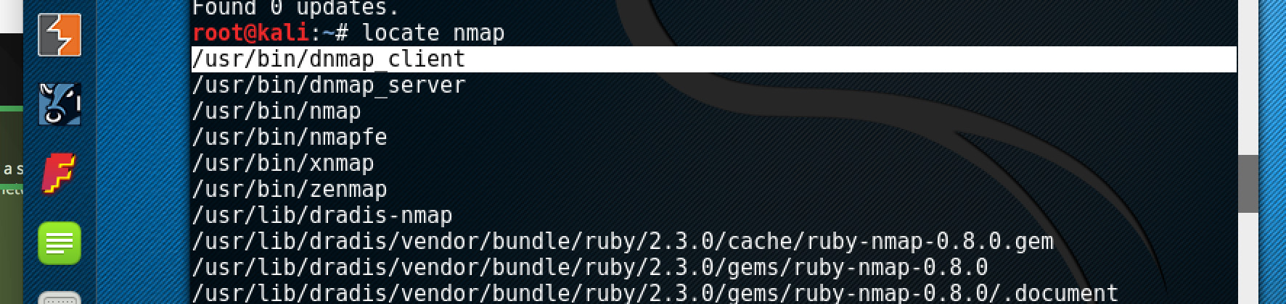

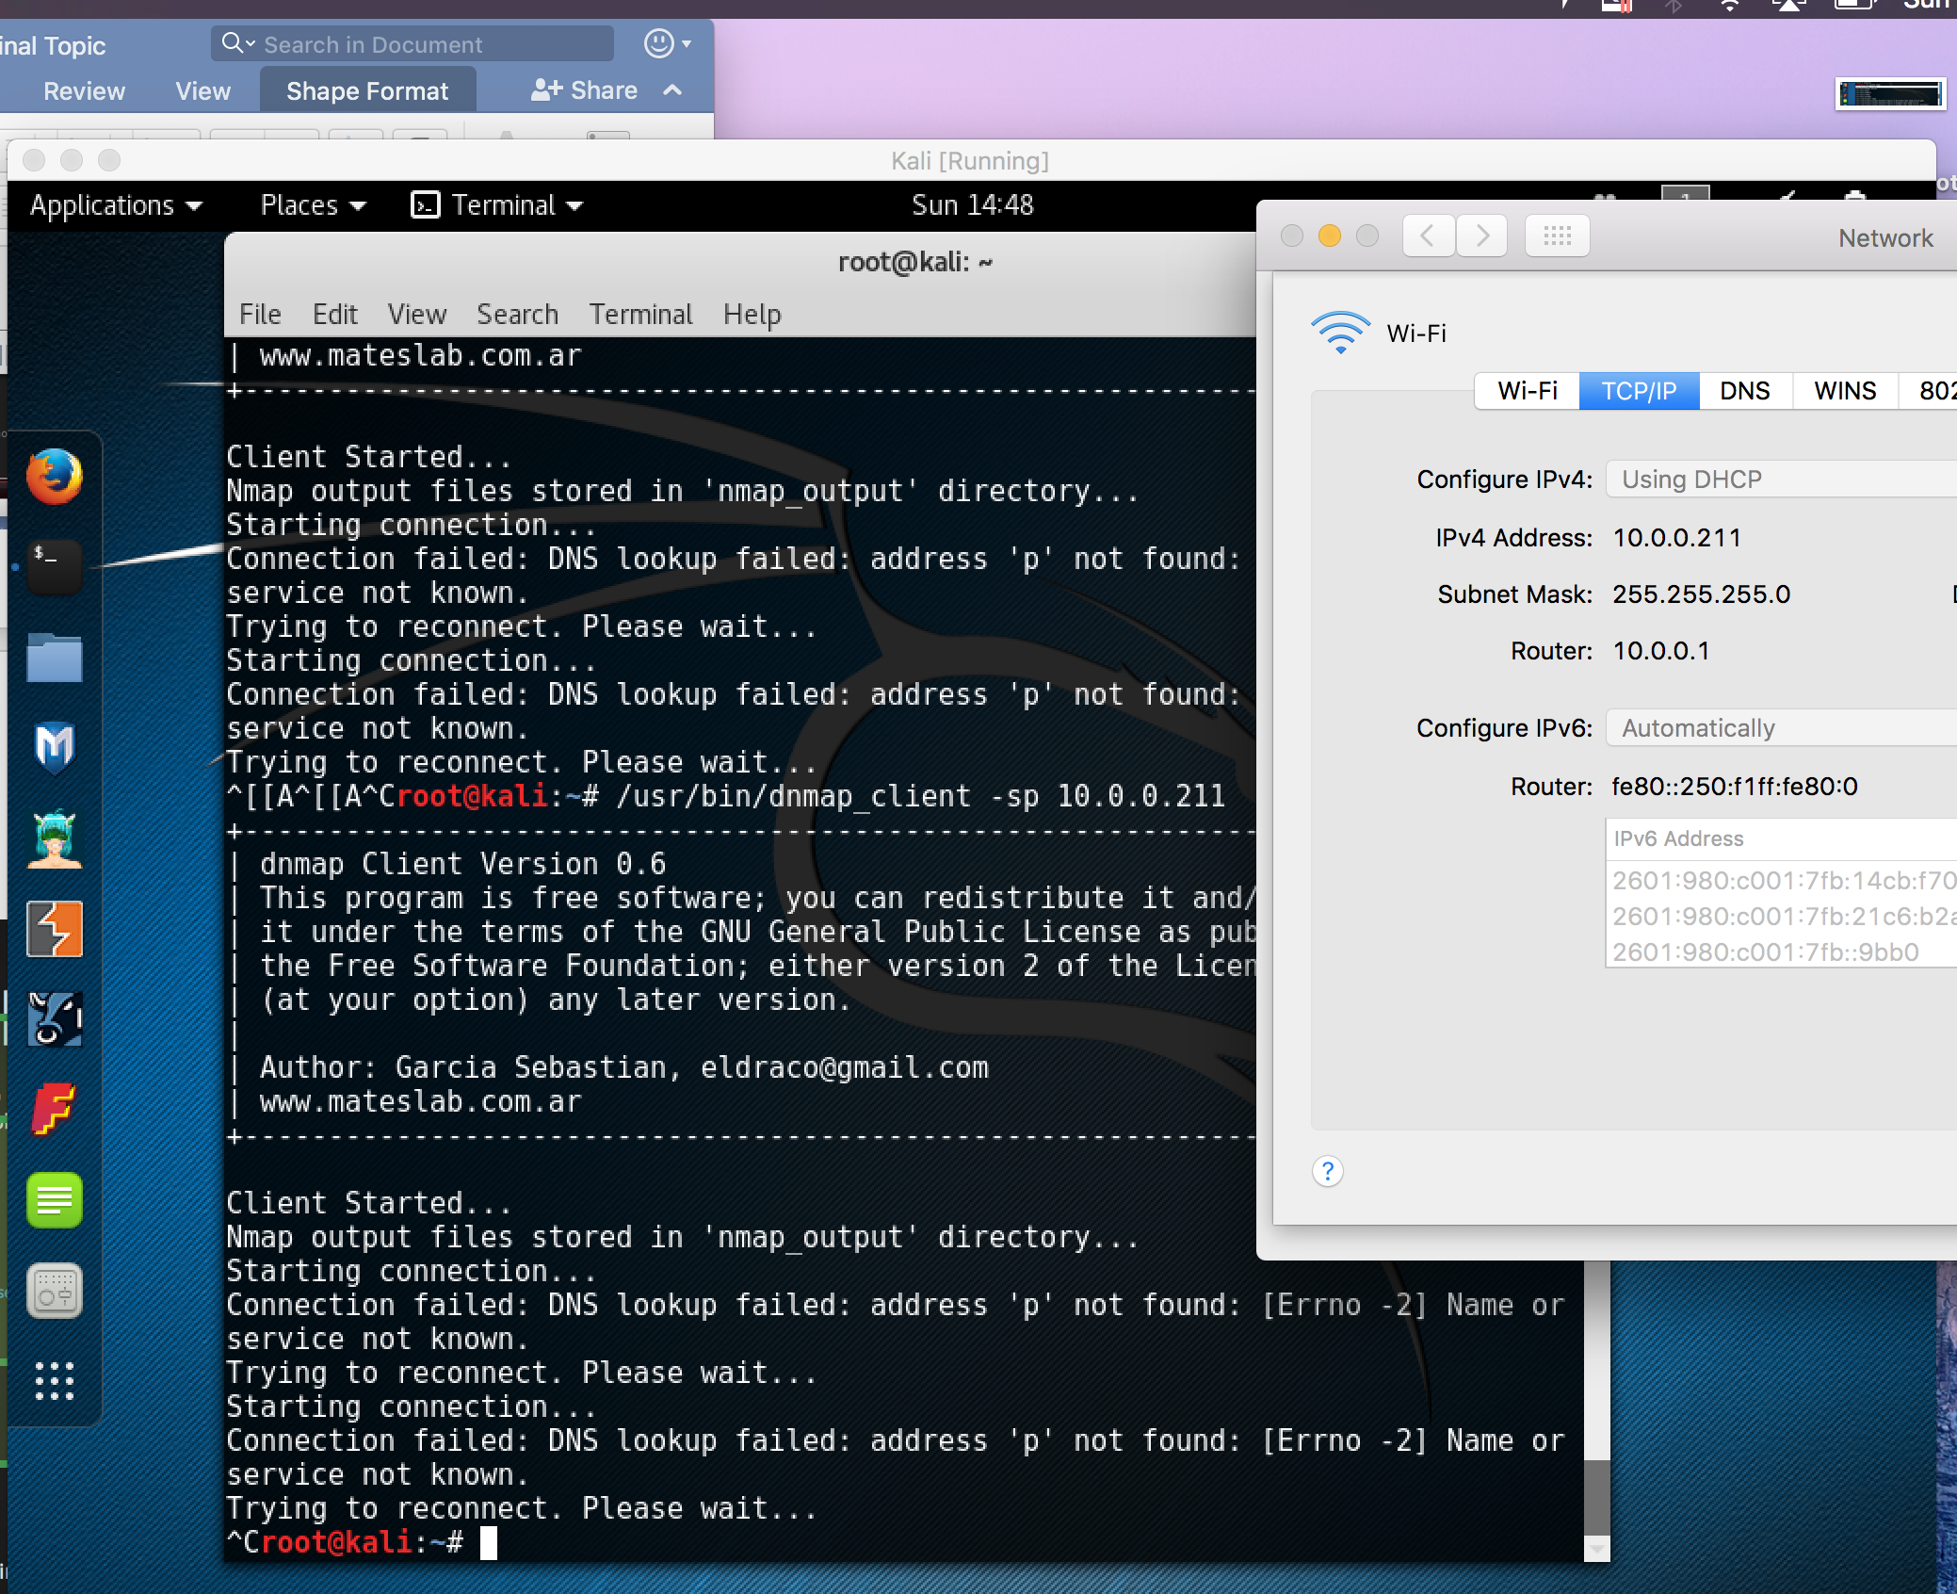



1. The command that I used was: /usr/bin/urlcrazy google.com
2. The green box shows the commands and the results.



